Press release
Eindhoven, 9 September 2020

A one-look overview of the city in 5 seconds
ITEA Award of Excellence for PS-CRIMSON

Cities nowadays are digitalising more and more service like data gathering for mobility, safety and communication to citizens. This data is required to be able to govern an increasingly dynamic and complex city. However, authorities still need to tackle information fragmentation caused by a lack of common platforms, toolsets and separated data per department. The ITEA project PS-CRIMSON, a collaboration of six academic and industry partners from the Netherlands and Canada, developed a unique 3D smart digital model that combines all the gathered data on one common platform. With this platform, public safety and disaster management can be improved, as pilot projects in Eindhoven and Vancouver have shown. Today, PS-CRIMSON was awarded with the ITEA Award of Excellence, exceptionally in two categories being Exploitation and Unique business partnerships.

The PS-CRIMSON consortium delivers a platform that serves as a single-entry point for city representatives. It facilitates data collection, sharing, management, analysis and dissemination from public and private urban infrastructures and resources. The entire city gets a single-entry point to a Smart City platform instead of having different types of systems between different departments. It saves them a lot of time and money and gives them one view of all the data they are gathering, enabling them to combine them and act upon them quickly. A focus lays on the public safety and disaster management domains, where the platform’s benefits are extremely important.

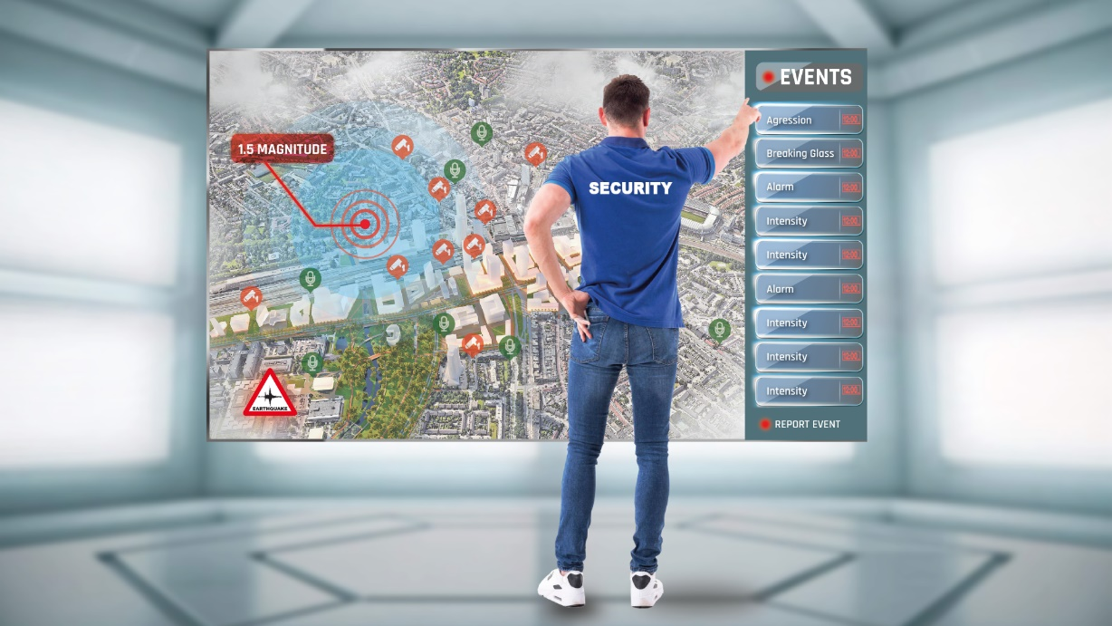

Improving public safety and disaster management
The City of Eindhoven and Vancouver were involved from the start, providing input on the design and implementation. This resulted in two technology demonstrators in two use cases, focusing on public safety and disaster management. The following scenarios illustrate the possibilities:

For public safety, a city responsible for video-surveillance currently might need to monitor up to sixty live-screens in the control room. In addition, (s)he receives dozens of calls during the day from local citizens and officers regarding suspicious events. Thanks to the PS-CRIMSON results, this person could now work with one single screen and, once logged in, virtually walk through a 3D model of the city and see everything that is happening in a single view.

On the background, software is monitoring all city data and filters out relevant events that require attention. This pre-processed information allows the city representative to make split-second decisions, see connections between the different data, and most importantly, feel in control. For example, when someone sends a mobile picture to the police, the search engine can determine on 10-meter accuracy where the incident is taking place. Walking routes of pedestrians can be connected between cameras throughout the city centre. Both are using special AI image technology developed by Eindhoven University of Technology.
The west coast of Canada is vulnerable to the huge earthquake fault running down the coast. Always upgrading their plans to protect Vancouver, a city of 2.5 million, city officials worked with Esri Canada using the strata plans to create a 3D smart model. The PS-CRIMSON application and model showed the effect of an earthquake which was 6.9 on the Richter scale, on the densely populated downtown. The application and model simulated the different scenarios and enabled the city to predict and pre-assess the damage with a much greater level of detail and accuracy. No longer looking at a census block level over 5-10 buildings, now they could see the effect, down to the level of interior units in the damaged buildings, and then see the effect of the different level of flooding that would follow.
“The PS-CRIMSON project showcased enhanced value streams and created new products that don’t exist in the emergency management realm. These value streams provide enhanced visualization above and below ground demonstrating impacts to our built environment. This allows emergency managers to derive detailed information at the building level supporting response efforts.”
– Kristopher Hayne, Emergency Management Analyst, Vancouver Emergency Management Agency

One team, one goal
The PS-CRIMSON partners show a unique complementarity in their collaboration; where Atos and Esri Canada offer the integrated platform, while ViNotion and Sorama are experts on sensoring, Esri Canada creates the digital twin city indoor modelling, Cyclomedia is responsible for the photo-realistic 3D texturing, and the Eindhoven University of Technology supports with innovative solutions on AI. Together they cover the full value chain for a Smart City solution, integrating the different silos of data and technology together in one common platform. In addition, with a number of the consortium partners a subsequent ITEA project called SMART has been set up. This clearly shows why they were the first to be awarded in the category of Unique business partnerships.
“The quality of the collaboration has been unique in the PS-CRIMSON project, taking advantage of the diversity of know-how and mastered technologies. This cooperative spirit was such that the partners have been able to extend it to commercial partnerships, which is always challenging. These partnerships have been successful in different worldwide calls for tenders. Another strong ITEA success story in the domain of smart city. Chapeau Bas to the complete team!”
– Philippe Letellier, ITEA Vice-chairman

First commercial global successes
Thanks to offering of a complete Smart City solution valued by the cities, the project already has its first commercial successes; they won a tender for Smart City Hilversum, which is now being deployed and similar projects are being implemented in Canada, United States and China. They are now the first adopters of the PS-CRIMSON platform to share valuable public data among different departments.

PS-CRIMSON’s offer enables the platform’s users to detect suspicious situations, localise them, follow the subjects involved and intervene before escalation takes place. Thanks to the project’s world-class technology results, that can be extended to many other domains, this can now all be done with a high performance and accuracy which is two to three years ahead of market, making cities a better and safer place to live in!
“International crises call for international responses, as we have learned during the COVID-19 pandemic. Being able to predict with much more accuracy the effect of an earthquake or flood on a city is a huge innovation in the area of public safety. As the only Canadian partner in PS-CRIMSON, I’m proud that Esri Canada is part of this effort.”
– Alex Miller President, Esri Canada

More information:
https://itea3.org/project/ps-crimson.html

Note for editors, not for publication
For interview requests, questions and additional information about ITEA, please contact:

PS-CRIMSON Contact person ITEA Contact person
Christopher Geelen Linda van den Borne-Toupet
christopher.geelen@vinotion.nl linda.van.den.borne@itea3.org
About ITEA
ITEA is a transnational and industry-driven R&D&I programme in the domain of software innovation. ITEA is a EUREKA Cluster programme, enabling a global and knowledgeable community of large industry, SMEs, start-ups, academia and customer organisations, to collaborate in funded projects that turn innovative ideas into new businesses, jobs, economic growth and benefits for society.
https://www.itea3.org

About ViNotion
ViNotion is a specialized company in the field of image analysis technology for automated observation of traffic including pedestrians and bicycles. The ViSense ® edge device, comprising state-of-the-art artificial intelligence (AI), is one of the core products that is being used by public authorities for video surveillance, crowd management, traffic analysis and traffic control, city marketing, retail statistics, and smart city concepts. All ViSense products are fully designed and produced within the company. The ViNotion strategic research programme focuses on development of new use cases for real-time observation. Customers are system integrators and manufacturers that use the ViSense technology as an OEM product.
https://www.vinotion.nl

About Esri Canada
Founded in 1984, Esri Canada provides geographic information system (GIS) solutions that empower people in business, government and education to make informed and timely decisions by leveraging the power of mapping and spatial analytics.
https://www.esri.ca

About Cyclomedia
Cyclomedia captures data from the real world and transforms it into valuable insights, enabling you to understand the complexities of the environment around you. With the world’s most accurate 360°street-level visualizations, enhanced by innovative, AI-powered analytics, Cyclomedia delivers actionable insights that you can use today in order to build a better tomorrow.
https://www.cyclomedia.com/en

About Sorama
From acoustic data to relevance. Sounds are all around us in many forms, from music to machinery and from applause to alarm-bells. Using acoustic technology, Sorama interprets ambient sound, converting it to a reliable source of relevant information. Control systems can immediately act on triggers which are derived from real-time acoustic events.
https://www.sorama.eu

About Eindhoven University of Technology
Eindhoven University of Technology (TU/e) is a research-driven university of international standing, where excellent research and education go hand in hand. TU/e is known for its strong research collaboration with industry. Our researchers work on pioneering technological solutions to societal challenges in the field of AI, sustainable energy, health and mobility. TU/e: where innovation starts.
https://www.tue.nl

About Atos
Atos is a global leader in digital transformation with 110,000 employees in 73 countries and annual revenue of € 12 billion. European number one in Cloud, Cybersecurity and High-Performance Computing, the Group provides end-to-end Orchestrated Hybrid Cloud, Big Data, Business Applications and Digital Workplace solutions. The Group is the Worldwide Information Technology Partner for the Olympic & Paralympic Games and operates under the brands Atos, Atos|Syntel, and Unify. Atos is a SE (Societas Europaea), listed on the CAC40 Paris stock index.
The purpose of Atos is to help design the future of the information space. Its expertise and services support the development of knowledge, education and research in a multicultural approach and contribute to the development of scientific and technological excellence. Across the world, the Group enables its customers and employees, and members of societies at large to live, work and develop sustainably, in a safe and secure information space.
https://www.atos.net

