Jean-François Lavignon takes the baton from Philippe Letellier and becomes ITEA Vice-chairman
Eindhoven, 7 September 2020

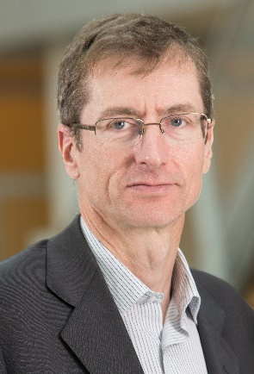
As of 1 September 2020, Jean-François Lavignon is the new ITEA Vice-chairman. He succeeds Philippe Letellier, who was the ITEA Vice-chair since 2008.
For the last four years, Jean-François Lavignon has provided services to SMEs helping them to exploit technological innovation and has worked to develop the European High Performance Computing ecosystem.
From 1998 to 2016, he has worked at Bull - which is now part of the Atos Group - where he was responsible for technological partnerships in the Big Data and Security Service Line. He has also been general manager of the HPC business unit, in charge of developing Bull’s business in the HPC market. Additionally, he has been the Chairman of the European Technology Platform for High Performance Computing (ETP4HPC).
He can draw from his extensive experience in ITEA thanks to his former participation in the ITEA Steering Group and his recent Board membership representing Atos.
Resigning Vice-chairman Philippe Letellier is very pleased with the appointment of Jean-François Lavignon: “After 12 years of involvement in ITEA I have been excited to push the bottom-up approach of ITEA to support our industry to innovate successfully, delivering impact on the market. The path has to be continued and I leave it with confidence in the hands of Jean-François Lavignon who has all the qualities to take it a step further with the support of the ITEA Presidium and Office.”
On his future role as Vice-chair of the ITEA Board, Jean-François Lavignon stated: “I am very pleased to join the ITEA Community again. Thanks to the effort of the Community members and to Philippe Letellier’s 12 years of dedication, commitment and technical leadership, I find an ITEA Community stronger than ever with more participants and a very strong industry focus. I am very excited to work with the ITEA Community to add some new chapters to this research and business success story.”
Check out his introduction video to learn more about our new Vice-chairman:
https://youtu.be/7Jwc-EpxCQA

Note for editors, not for publication
For interview requests, questions and additional information about ITEA, please contact:

ITEA Contact person
Linda van den Borne
linda.van.den.borne@itea3.org

About ITEA

ITEA is a transnational and industry-driven Research, Development and Innovation (R&D&I) programme in the domain of software innovation. ITEA is a Cluster programme of EUREKA, an intergovernmental network for R&D&I cooperation, involving over 40 countries globally. ITEA is the home of software innovation, enabling a large international community to collaborate in funded projects that turn innovative ideas into new businesses, jobs, economic growth and benefits for society.

It covers a wide range of business opportunities facilitated by digitisation like smart mobility, healthcare, smart cities and energy, manufacturing, engineering and safety & security. ITEA pushes important technology fields like artificial intelligence, big data, simulation and high-performance computing into concrete business applications.
ITEA is open to large industry, small and medium-sized enterprises (SMEs), start-ups, academia and customer organisations and its bottom-up project creation ensures that the project ideas are industry-driven and based on actual customer needs.

The ITEA programme is publicly funded on a national level; each ITEA project partner can apply for funding from their own national Public Authority.

More information: https://itea3.org

